PCI–DSP
Conventional PCI–DSP
- (-) Non-standard Linux/Windows kernel mode device drivers
- (+) Available 3 McBSPs (or GPIO)
- (-) Needs PCI slot
- Up to 4 DSPs to one PCI bridge

B.O.M. @ 100 pcs

$17 TMS320VC5410APGE16
$10 PCI2040
$1 SN74CBTD3861DL (2x)
$3 TPS767D301PWP
$1 SN74LVC1G08DBV (2x)
Feeling: Better for high density modules / devices

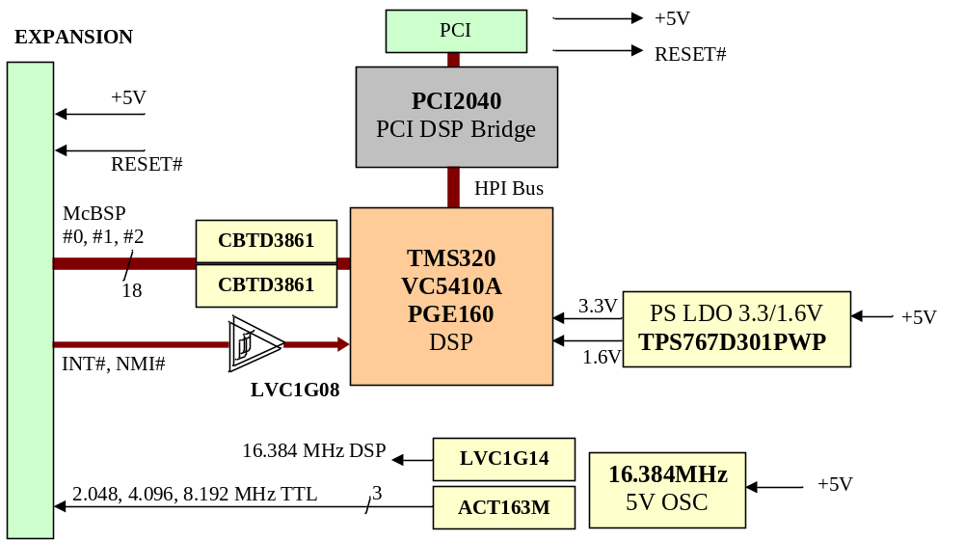 CD74ACT163M

$3 OSC16.384MHz, 5V

$1 HDR 2x13 (expansion)

Optional
$1 SN74LVTH16245ADL
$1 SN74LVC1G07DBV
HDR 2x20 (hpi)

Manufacturing
$14 PCB 60x80 FR4 4-layers
$13 Assembly

$65 TOTAL

USB–DSP
USB–DSP
- (+) VCP: standard USB COM device & wide support (Linux, Windos etc.) See:
http://www.ftdichip.com
- (-) Available 2 McBSPs (or GPIO)
- Max. 1 MBy/s transfer rate
- Possible PS from USB (max 2.5W)
- EEPROM contains just DSP monitor & bootloader program
B.O.M. @ 100 pcs
Feeling: Better for low density (e.g. up to 4 port) devices.

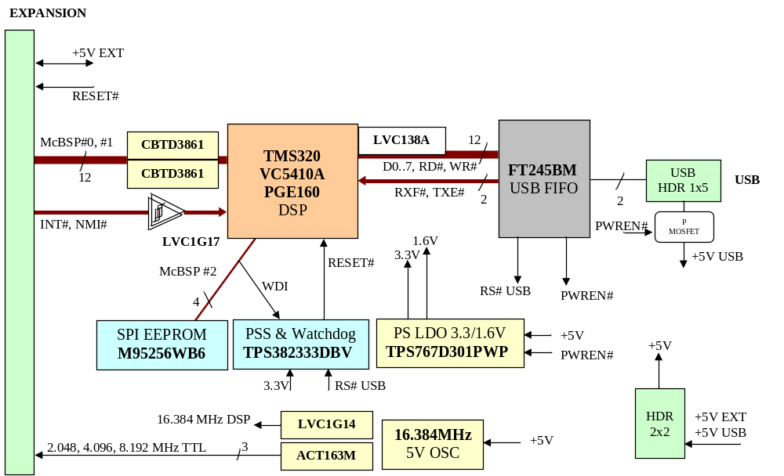$17 TMS320VC5410APGE16
$5 FT245BM
$1 SN74CBTD3861DL (2x)
$3 TPS767D301PWP
$1 TPS382333DBV
$2 SN74LVC138ADB
SN74LVC1G14DBV
SN74LVC1G08DBV (2x)
CD74ACT163M
$4 M95256WB6 & DIL socket

$3 OSC16.384MHz, 5V
$1 XTAL 6MHz

$1 HDR 2x13 (expansion)
HDR 1x5 (usb)

Manufacturing
$7 PCB 60x80 FR4 2-layers
$13 Assembly

$58 TOTAL

Note: although USB version seems
more complicated than PCI, in fact
it is much simpler. No goldfinger,
much less wires and simpler PCB,
simpler & standard device drivers,
cheaper etc.
USB-PCI + Optional HPI

$1 SN74LVTH16245ADL
$1 SN74LVC1G07DBV
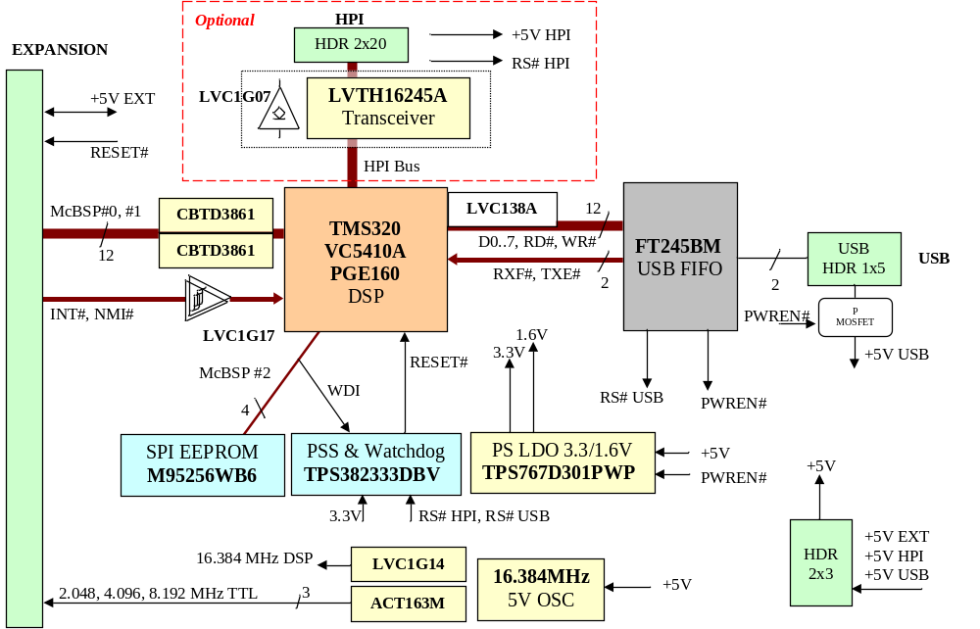 HDR 2x20 (hpi)

- Direct connection
to PC104-HPI8.

- Used in development.
USB–HPI8
Test USB idea. Connection of current hardware. Windows development.

B.O.M. @ 100 pcs

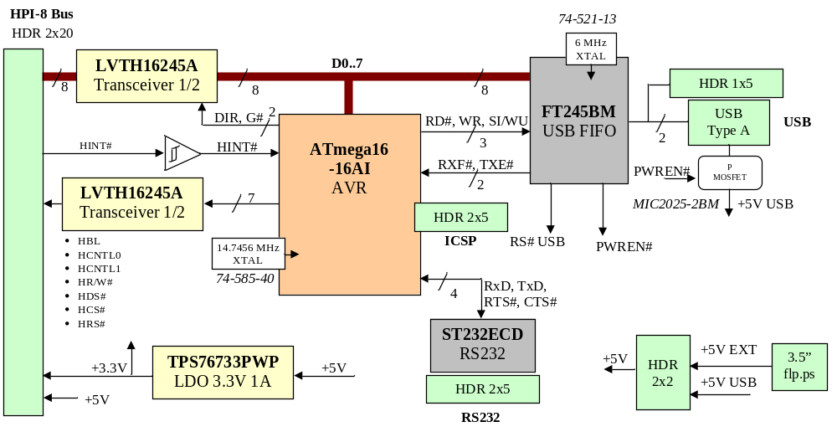$5 FT245BM
$6 ATmega16-16AI
$1 SN74LVTH16245ADL
$2 TPS76733PWP
$2 SN74LVC1G17DBV
$1 ST232ECD
$2 MIC2025-2BM

$1 XTAL 147.7456MHz
$1 XTAL 6MHz

$2 HDR 2x20 (expansion)
HDR 2x5 (ICSP)
HDR 2x5 (RS232)
HDR 2x8 (LCD)
$1 USB Type A

Manufacturing
$5 PCB 60x80 FR4 2-layers
$10 Assembly

$39 TOTAL
D0 – D7 8 I/O
G#, DIR 2 Output
HINT# 1 Input
A0 – A6 7 Output
RS232 4
ICSP 4
RD#, WR, SI 3 Output
RXF#, TXE# 2 Input
Total ATmega 31 pins

